Biology, Castle View High School  
Jason R Mayberry, PhD

**Study Guide: Chemical Reactions**

**Vocabulary**:

1. Physical Change
2. Chemical Reaction
3. Reactants
4. Products
5. Reaction Equation
   1. Coefficients
   2. Subscripts
   3. Balanced
6. Chemical Energy
7. Exergonic Reactions
8. Endergonic Reactions
9. Energy of Activation
10. Intermediate State
11. Catalyst
12. Enzyme

**Conceptual Questions**

1. Describe what happens to molecules during a chemical reaction.

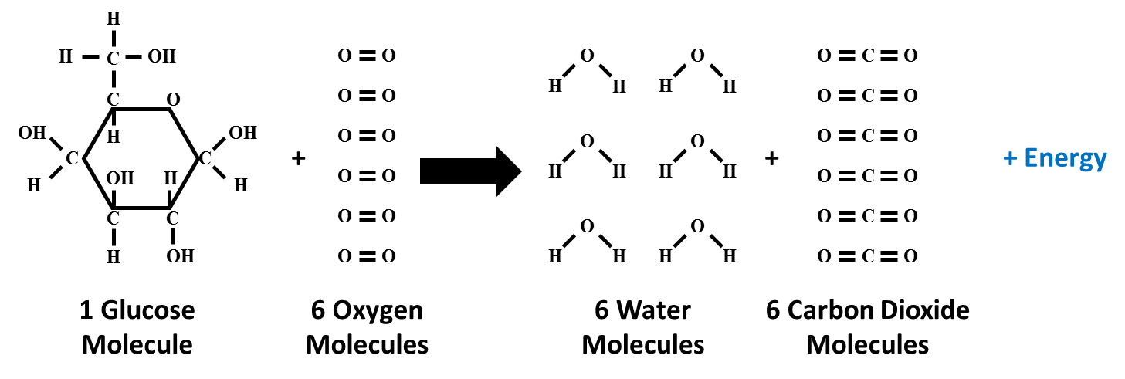

1. Describe how a reaction equation depicts what happens in a chemical reaction. What does it mean for a reaction equation to be **balanced?**



1. Write the reaction equation for the chemical reaction depicted below.

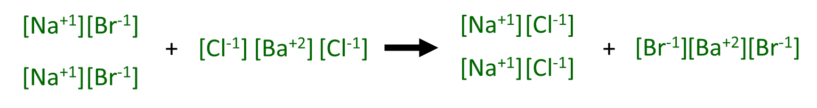

1. Generally speaking, describe what happens during a chemical reaction to absorb or release energy? (i.e. what is the source of energy in the molecules?)

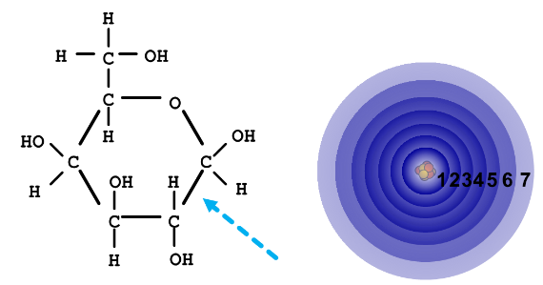

1. How do High Energy Chemical Bonds differ from Lower Energy Chemical Bonds?
2. Describe how the energy changes during exergonic and endergonic reactions (i.e. draw a graph for each).
3. What is physical reason that the Energy of Activation is needed to initiate a chemical reaction, even exergonic ones?

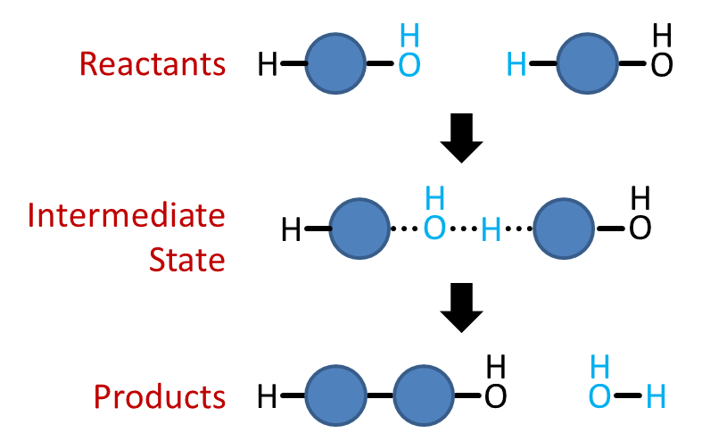

1. How does a catalyst increase the rate of a chemical reaction?